

**Modeling of long-term and conditional volatility dynamics in high-frequency returns at fixed trading time points using a general Semi-GARCH model**

Masterarbeit

Im Fachbereich Ökonometrie und quantitative Methoden

vorgelegt von: Xiaojing Hou

betreut durch: Prof. Yuanhua Feng

vorgelegt am:

Studiengang: Betriebswirtschaftslehre

Matrikelnummer:6750480

E-Mail Adresse:houxiao0129@gmail.com

Paderborn, den x.y.2014

# Abstract

# Contents

Abstract II

Contents III

1 Introduction 1

2 Parametric models 3

2.1 Parametric GARCH model 3

2.1.1 Definitions and basic properties 4

2.1.2 Stationary of GARCH model 4

2.1.3 Estimation of GARCH model 5

2.2 Parametric asymmetric power ARCH model 6

2.2.1 Definition of APARCH model 7

2.2.2 Stationary of APARCH model 7

2.2.3 Special cases of APARCH model 7

2.3 Parametric exponential GARCH model 8

2.4 Parametric component GARCH model 10

2.5 Conclusion 11

3 Semi-parametric models 12

3.1 Semi-parametric GARCH model 12

3.1.1 Definition of semi- parametric GARCH model 12

3.1.2 Estimation of semi-parametric GARCH model 12

3.1.3 Asymptotic properties of 14



3.1.4 The selection of bandwidth 15

3.2 Semi-parametric APARCH model 16

3.2.1 Definition of semi-parametric model 16

3.2.2 Estimation of the semi-parametric APARCH model 17

3.3 Semi-parametric EGARCH model 18

3.4 Semi-parametric CGARCH model 18

3.5 Conclusion 19

4 Application of semi-parametric models 20

4.1 Data description 20

5 Conclusion 33

Reference 34

# 1 Introduction

Trading off risks against returns appears to be essential and vital for making a financial decision. Hence the econometric analysis of risk (volatility) becomes an important part in forecasting market tendency and supporting making financial decisions, such as portfolio diversification, risk management and derivative pricing. In the last 20 years volatility was a research hotspot in financial industry. Volatility is regarded as a parameter for evaluating the risk of assets return. Generally, the stronger the volatility is, the higher the risk is.

In the traditional financial models, the variance of the time series is always assumed as constant. However, it is found that the volatilities of financial time series have always the features of “clustering” and “fat tails” (Mandelbrot 1963) (Eugene F. Fama 1965). These features obviously are not consistent with the assumption of constant, so the traditional econometrical methods cannot analyze the time series variables efficiently in practice. To overcome this problem, several economists have carried out studies on researching and developing frameworks for evaluating volatility. Since Engle introduced the autoregressive conditional heteroskedasticity (ARCH) model (R. F. Engle 1982), the extensions of ARCH model appeared and spread rapidly. Among the carried out researches, the Generalized ARCH (GARCH) model and its derivatives are most widely used (Bollerslev 1986).

Instead of parametric models or nonparametric models, recently proposed semi parametric models will be introduced in details in this paper. According to many studies (Gourieroux and Monfort 1992) (Eubank and Härdle 1993), preselected parametric models might be too restricted or too low-dimensional, which may not fit unexpected features and cause the misspecification. However, in nonparametric models, the parameters of the model cannot be estimated, and the model cannot be explained due to lack of specific functions. The semi parametric models do not need a pre-specified function and is less sensitive to model misspecification. At the same time, the model can be also explained (Di and Gangopadhyay 2011).

In this paper, the definition, estimation, some properties of semi-parametric models and the methods of bandwidth selection are discussed. Furthermore, according to the study of the semi-parametric GARCH model and semi-parametric asymmetric power ARCH model, which are introduced by Feng (Feng 2004) (Feng and Sun 2013), the semi-parametric method will be (尝试着) entered into exponential GARCH and component GARCH models. Then, the discussed semi-parametric models, i.e. semi-parametric APARCH, EGARCH and CGARCH models, are applied to the stock prices of BMW and Allianz from January 2006 to September 2014. Different from other papers, to get the more exact analyzing results the fixed trading time points will be used in this paper. (Lack of a simple conclusion of the analysis)

The plan of this paper is as follows. In section 2 the parametric models are introduced. The semi-parametric models are described in section 3. Section 4 reports the application of the semi-parametric models to the stock prices of BMW and Allianz and the empirical results on the volatility of the selected prices. Finally, this paper is concluded in section 5.

# 2 Parametric models

It is known that, volatility clustering exists in financial time series, and the distribution of random variables appears the fat tails. Mandelbrot observed the pattern of thick tails or fat tails of stock prices fluctuation, which was not consistent with the traditional assumption of normal distribution, by study the stock price index in 1963 (Mandelbrot 1963). Fama (1965) suggested that the financial market returns had the property of volatility clustering. It means that volatility is not only dynamic but also clustered, which appears strong in one certain period but weak in another period. The reasons for these phenomena could be traced back to speculation, political changes, government monetary and fiscal policy, and etc. (Eugene F. Fama 1965). “Volatility clustering” and “fat tails” cannot be explained by the traditional economic models, which assume the variance is constant, until the Autoregressive Conditional Heteroscedasticity (ARCH) model was introduced by Engle (1982) (Bollerslev, Chou, and Kroner 1992).

Different from the traditional models, ARCH model suggests that the conditional variance could change over time as a function of past errors with the unconditional variance remaining constant (R. F. Engle 1982). ARCH model soon became an important tool of volatility measurement, because it improved the traditional model and fit reality better. However, there are some drawbacks in ARCH model. In practical applications of the ARCH model, a relatively long lag in the conditional variance equation is often required, which might lead to increase in complexity of estimating parameters and decrease the freedom degree. When the lag order is high, estimating a totally free lag distribution will often violate the constraint of non-negativity parameters. But the restrict condition is exactly needed in this model to ensure conditional variance to be non-negative (Bollerslev 1986). Therefore, there are many economists tried to improve ARCH models. Among these researches, the generalized ARCH (GARCH) model, which is introduced by Bollerslev (1986), is the most widely well-known one with a better framework to study time-varying volatility in financial markets.

## 2.1 Parametric GARCH model

GARCH model added the lagged conditional variances to ARCH model, so that it has a longer memory and a more flexible lag structure than ARCH model.

### 2.1.1 Definitions and basic properties

In GARCH model,  denote the set of the past information. The GARCH process is presented in equation (2.1),

. (2.1)



In which  is a random variable; $η_{t}$ are i.i.d. random variables with zero mean and unit variance;  means the conditional variance of and is defined as follow:

(2.2)



where $ω$ >0 is the variances intercept parameter; p>0 is the order of ARCH parameters; q $≥$ 0 is the order of GARCH parameters; $α$ and $β$ ($α_{i}≥0, i=1,…,p; β_{j}≥0, j=1,…,q$) are two vectors of unknown parameters respectively (Bollerslev 1986).

From the model we can see that, GARCH model contains the lagged conditional variances in addition to ARCH model. When q=0, the process is ARCH model; if p=q=0, this process is a simple white noise; while , this process is an infinite dimensional ARCH $(∞)$. That means that ARCH is a special form of GARCH process. Most of the cases, a high order ARCH model can be replaced by a low order GARCH model without breaking the constraint of non-negativity by estimating too many parameters. For example, In the application of ARCH (p) model, sometimes the value of p is very high; but for GARCH (p, q) model, p=1, q=1 are enough to achieve the same outcome (R. Engle and Bollerslev 1986).



### 2.1.2 Stationary of GARCH model

In the paper from Engle, he introduced the stationary of GARCH model. As it is known, a process {} is weakly stationary, if i) for all , ii) and are independent of t for, (Bougerol and Picard 1992).



So the GARCH (p, q) process with and for is wide-sense stationary if and only if [Theorem 1. from Bollerlov 1986].



### 2.1.3 Estimation of GARCH model

Usually, the maximum likelihood estimation is most widely used to estimate GARCH model. Besides the condition of stationary, to estimate GARCH model, a very important assumption is finite fourth-order moment, which ensures the existence of the squared returns variance. Assuming GARCH model is a normal process:

. (2.3)



Under this condition, if and only if for GARCH(1,1) model (Milhj 2012).



Letting , the conditional Gaussian log-likelihood function is defined as follows:



. (2.4)



where

. (2.5)



Then maximize L() by calculating and putting the partial derivatives to zero. After n times iteration, the approximated value (MLE) of is obtained, which is denoted as .



The maximum likelihood method is used by most of cases in GARCH family. Based on the assumption of normal distribution, GARCH model can partially explain the clustering and fat tails properties of the returns’ unconditional distribution. However, after the standardized by GARCH model, the residuals also have the properties of clustering and fat tails, which is not consistent with the normal assumption. So Bollerslev and Nelson used student-t distribution and generalized error distribution (GED) instead of normal distribution to estimate GARCH models (Bollerslev 1986) (Nelson 1991). When we estimate other GARCH models, which will be discussed below as examples, the main method is the same, maximum likelihood method. The most significant difference is the assumption of the distribution.

Although a simple GARCH model can solve the problem of the ARCH model with high-order linear declining lag structure, it also has some obvious drawbacks. The two constraint conditions of GARCH model, parametric non-negativity and bounded, restrict its applicability. The assumption of non-negative parameters raises the difficulty of estimation. Also with this assumption, the GARCH model cannot well explain the asymmetry of volatility and leverage effects. In order to extend the application of GARCH model, many GARCH derivatives appeared aiming at different problems. For example, to explain the asymmetry of volatility, the exponential GARCH model (EGARCH) was proposed by Nelson (Nelson 1991), and threshold GARCH (TGARCH) was suggested by Zakorian (Zakoian 1994). Ding, Granger and Engle introduced the APARCH model (Ding, Granger, and Engle 1993), which are able to explain the leverage effects in financial market better. Engle and Lee defined the component GARCH (CGARCH) model to exactly interpret the shock influences to the long-run and the short-run volatility respectively (R. F. Engle and Lee 1999).

## 2.2 Parametric asymmetric power ARCH model

Generally, if a data series follows the normal distribution, we can characterize it by its first two moments. However, if the error of the data follows a non-normal distribution, then higher moments of skewness, kurtosis have to be applied, which describes the data beyond to adequately. In this instance, other power transformations appeared to be more appropriate than squared term (McKenzie and Mitchell 1999). Ding, Granger and Engle (1993) further studied the autocorrelation of square returns and absolute returns based on GARCH model and Taylor model. It is found that, long lags between absolute or square returns are more correlated than the returns themselves for the return process (Taylor 1986). Furthermore, has the largest autocorrelation when d is around 1, but smaller monotonically one when d deviates from 1. Based on this they imposed an asymmetric GARCH model, asymmetric power ARCH model, which enables the power of the heteroskedasticity equation to be estimated from the data.



### 2.2.1 Definition of APARCH model

The parametric asymmetric power ARCH model is defined by

. (2.6)



where , , ; is the leverage parameter, which takes the asymmetric news impact on the volatility into account, and is the parameter for the power term, which is a suitable positive number.



This model exhibits a power transformation of the conditional standard deviation process, which can linearize nonlinear models. It also reveals the asymmetric absolute residuals, which can reflect the leverage effect of the stock market returns.

### 2.2.2 Stationary of APARCH model

In APARCH model, when is conditional normal, and



, (2.7)



which is the condition to ensure the existence of and , then when , is covariance stationary (sufficient condition) (Ding, Granger, and Engle 1993).



### 2.2.3 Special cases of APARCH model

In the cases of the values of and are changed, APARCH model derives into several models, the GJR-GARCH model, the TS-GARCH model (Taylor and Schwert model), the NGARCH model (Nonlinear GARCH model) and the TGARCH model (threshold GARCH model).



When =2 and =0, the APARCH model turns into a GARCH model with the covariance stationary for as (Bollerslev 1986).



When , the APARCH model can be named as the GJR (Glosten, Jagannathan and Runkle, 1993) model



(2.8)



with the covariance stationary for  as . This model uses the indicator function I to simulate the asymmetric influence of the positive and negative shocks on the conditional variance (Glosten, Jagannathan, and Runkle 1993).



When , the APARCH model transforms into the TS-GARCH model



(2.9)



with the covariance stationary for  as (Taylor 1986)(Schwert 1990).



When , the APARCH model becomes the TGARCH (threshold GARCH) model



(2.10)



with the covariance stationary for , the same as TS-GARCH model, as (Zakoian 1994)



## 2.3 Parametric exponential GARCH model

It is considered that, GARCH model has taken the focus on the magnitude matters of excess return, but ignored the information of directions. Moreover, it is proven by empirical evidence that the direction does impact on volatility. Especially for broad-based equity indices and bond market indices, it is observed that market declines forecast higher volatility than comparable market increases do (R. Engle 2001). In addition, the estimated coefficients often violate the parameter restrictions in GARCH model. It is also found that the left tail of the returns distribution was fatter than the right one. The reason is generally considered as the asymmetric response of investors to “good news” and “bad news” (Jondeau and Rockinger 2003). To solve this problem Nelson (1991) imposed the exponential GARCH model.

Instead of making  a linear combination of positive random variables, EGARCH model ensure that  remains nonnegative by making ln() linear in some function g of time and lagged  ‘s.

The exponential GARCH model can be written as follows:

 (2.11)

where

. (2.7)

In this model, $β_{1}≡1$; $α$ and $β$ are real, non-stochastic and scalar sequences; g() is a i.i.d. random sequences with zero mean (Malmsten 2004).

EGARCH model provides a good solution for the problems of GARCH. There is no constraint for parameters. The function g() contains two parts,  that define the size effect, and  that defines the sign effect of the shocks on volatility. The size effect is a typical ARCH effect, but the sign effect is asymmetrical. For example, the leverage effect (Black, 1976), which means that volatility rises in response to negative shocks and falls in response to positive ones.

According to the Theorem 2.1 in (Nelson 1991), when  and  do not equal to zero at the same time, the EGARCH process is strictly stationary and ergodic if and only if .

The estimation of EGARCH model is mostly same as the estimation of GARCH model. The difference between them is that, in EGARCH model, the generalized error distribution (GED) is used. Because this distribution includes the normal distribution as a special case; and when the process is strictly stationary and the distribution of  is not too fat tailed, and  have finite unconditional moments of arbitrary order (Nelson 1991).

## 2.4 Parametric component GARCH model

It is known that the stock prices always fluctuate around an average value. This phenomenon is called mean-revert. It is also found that mean-revert of short-term volatility is more rapid than for the long-term one (Xinzhong Xu and Stephen J.Taylor 1994). In order to explain this different response between short-term and long-term, Engle and Lee (1999) imposed component GARCH model. In this model, the conditional variance is decomposed into a permanent and transitory component. So that the model can be used to investigate the long-run and short-run movements of volatility affecting securities.

The component GARCH model is defined by

(2.10)



(2.11)



where is the permanent component of the conditional variance and is the transitory component of the conditional variance (Ghalanos 2014); is the mean-revert of . In terms of economy, the smaller the mean-reverting rate, the less persistent the expected volatility to market shocks in the past. That means, when the market receives the information of shocks, volatility responses quickly but has lower persistence. If 0<<1, the mean-reverts of short-run volatility component is zero at a geometric rate of ; If , the long-run volatility component follows an AR process, and will converge to a constant level defined by . In this model, the long-run component is more persistent than the short-run one, i.e., .



In GARCH model, the conditional variance must be non-negative. This condition is also required in component GARCH model. But this is not demanded by , which can be positive or negative over time to exhibit the self-correction feature of the mean-reverting volatility process. The condition of stationary in GARCH model is , besides which this stationary condition also includes and requires in component model. When , the mean series is not a covariance stationary process, but a strictly stationary and ergodic process.



From the above analysis, the stationary conditions of component GARCH model can be concluded as . But they are just sufficient conditions, not necessary ones (R. F. Engle and Lee 1999).



## 2.5 Conclusion

Parametric GARCH model has many advantages. The function form is accessible, and parameters could be easily estimated. If the model assumptions were correct, the estimation is consistent with reality. However, the drawbacks of parametric models are more disgusting. Firstly, a preselected parametric model may not fit unexpected features, due to too restricted or too low dimensional. Secondly, sometimes the regression function seems to be too complicate or difficult to be defined. Thirdly, because different sequence will be witnessed when different conditional distribution is selected in the process of prediction by using parametric models, there will most possibly exist the problem of misspecification，which may result in a excessively high model bias and loss of efficiency, unless the assumed function perfectly matches the true error distribution (Di and Gangopadhyay 2011).

# 3 Semi-parametric models

Gourieroux and Monfort had firstly inserted the conditional mean and conditional variance into a nonparametric model, in which the function form is not given. This model can supply the gaps of parametric models. Correspondingly, it is less sensitive to model misspecification and can offer a flexible tool in analyzing unknown regression relationships (Gourieroux and Monfort 1992). In nonparametric regression models, both the error distribution and the functional form of the mean function are not pre-specified. It will be more useful when the regression function seems to be very complex or a suitable function form cannot be found (Eubank and Härdle 1993). However, the nonparametric models lose some functions, which can be completed by parametric models. Due to lack of specific function forms, the parameters of the model cannot be estimated; furthermore the model cannot be explained. Excess variable estimates could rise up because of poor consideration of nonparametric models, especially for small sample size (Fisher). So a new model, semi-parametric model, is proposed.

Semi-parametric model consists of not only the nonparametric part but also parametric part. Semi-parametric GARCH model selects the nonparametric form for the scale function and the parametric part for conditional variance lags. Then it does not need a pre-specified function form and is less sensitive to model misspecification. At the same time, the parametric part can also explain the models (Di and Gangopadhyay 2011).

## 3.1 Semi-parametric GARCH model

### 3.1.1 Definition of semi- parametric GARCH model

Semi-parametric GARCH model combines a smooth scale function with the standard GARCH model:

(3.1)



where is an unknown constant; ; is the nonparametric component, a smooth, bounded scale function; and {} is the parametric component, which is assumed to follow a GARCH(p, q) process.



(3.2)



(3.3)



where are independent and random variables; ; and . To estimate ,  is assumed to ensure function (3.3) strictly stationary (Feng 2004).



### 3.1.2 Estimation of semi-parametric GARCH model

The estimation of semi-parametric GARCH model can combine the nonparametric estimation of the Y’s local variance v(t)= with parametric estimation of the unknown parameter vectors .



Firstly, v(t) can be estimated by some nonparametric regression approach consistently without any parametric assumptions. In this paper the kernel estimation will be used to estimate v(t). Model (3.1) needs to be transformed into a general nonparametric regression problem at first. Let , and , which are zero mean stationary time series errors. Then the model (3.1) can be rewritten as .



Let and , in which is then defined by . A Nadaraya-Watson kernel regression， which has been proposed by Nadaraya (1964) and Watson (1964), is defined as



(3.4)



where is the weighting function ; K(u) is a second order kernel function with compact support [-1,1]; and b is the bandwidth, the size of the weights (Fan and Truong 1993).



According to the above assumptions, the estimator is now replaced by the standardized residuals



. (3.5)



Then the estimator of parametric vector can be obtained by the standard maximum likelihood method, which has been introduced in section 2.



There exists boundary problem in kernel regression. At the boundary, fewer observations can be averaged, and the estimation at the boundary points will cause larger bias than the ones at the interior because of the asymmetry in the observations. This phenomenon is called boundary problem. Local linear estimator can be used to overcome this problem but may result in negative estimation sometimes. To improve the boundary problem in kernel regression, the kernel estimator is introduced (Feng, 1998) (Eubank and Härdle 1993).

### 3.1.3 Asymptotic properties of



The estimators of kernel regression function approximate the real value asymptotically. There also exists the bias between the real v and the estimators of kernel regression function .

To calculate the bias, several assumptions must be satisfied:

A1.  ensures the process strictly stationary, and  (Ling and McAleer 2002).

A2. The second derivative of v(t) exists and is continuous on [0,1].

A3. The kernel K(u) is a continuous function, which is symmetric around zero and defined in [-1, 1].

A4. When the sample volume , the bandwidth and . Then both of the bias B and the variance V approaches zero.



Define and . Under these assumptions, the asymptotic bias and the asymptotic variance can be obtained.



The asymptotic bias B of (t) is:

. (3.6)



The asymptotic variance V of (t) can be expressed as:

. (3.7)



From (3.6) and (3.7) we can see that, bias is of the order b2 and the variance is of the order 1/(nb). The bias has the positive correlation with the bandwidth, whereas the variance has the negative correlation with the bandwidth. The higher the v(t), the larger the variance; and the more complex the v(t), the larger the bias.

Under the assumptions, the asymptotic MISE can be calculated by:

. (3.8)



By minimizing the dominant part of the asymptotic MISE, the asymptotically optimal bandwidth of is



. (3.9)



When the bandwidth is of order , we can get and (Theo Gasser and Müller 1984) (Fan 1991).



### 3.1.4 The selection of bandwidth

Applying the estimator  requires the specification of kernels and bandwidth. Optimal kernels have been obtained analytically. The selection of bandwidth becomes the most important problem when applying nonparametric regression estimators such as kernel estimators. Small bandwidth will reproduce the data, while large bandwidth will result in an over smooth curve. The regression works well, only if the bandwidth is suitable. Because the kernel estimation uses the points around to estimate the scale function, a kernel regression is usually biased. The larger the bandwidth, the larger the square bias because further points from  are used, but the smaller the variance because more observations are used for estimation. The bandwidth should be optimized to balance the variance and bias. The optimal bandwidth is the one, which can minimize the mean squared error (MSE) or mean integrated squared error (MISE) (T Gasser, Kneip, and Kohler 1991).



There are many methods available to optimize bandwidth, e.g. Cross-Validation (CV), Generalized CV (GCV), plug-in and etc. In this paper, CV and plug-in will be introduced in detail.

**Cross-Validation (CV)**

The Cross-Validation method is also called “leave-one-out”. This method estimates the MSE by leaving one observation out at each time point. The main idea of CV is that, the estimation of v() is without using , rather assess the quality of the estimation with other observations.



Define the estimation errors by . The function to calculate CV is:



(3.10)



where is the “leave-one-out’ estimator of v().



Let , , where m is an integer. Then the optimal bandwidth can be obtained by calculating the value of CV at …, . The optimal bandwidth is the one, at which CV(b) is minimized (Sarda 1993).



The reason of leaving the i-th point out is that, if the observation is used, there is always a bandwidth to be selected, which is small enough, to satisfy for any i, thus minimizes CV.



Cross- Validation is the most simple method for bandwidth selection and easy to understand. However, this method has large variability, which leads often a suboptimal nonparametric fit of the regression function. For example, the selected bandwidth by CV is often very large. Sometimes the resulted band width can be very small and wrong (Altman and Léger 1995).

**Plug-in bandwidth selected method**

In this method, some adapted assumptions are required. A) The function v(t) is strictly positive on [0,1] and exist at least continuous fourth moment. B)  is estimated with a symmetric fourth order kernel for estimating the second derivative with compacted support [-1,1]. C) The bandwidth b satisfied  and  as .

Denote , where  is the spectral density of  with is the autocovariance function of . Then the asymptotic optimal bandwidth can be rewritten as



where  with the assumption, the functions  and  have no common roots. is a nonparametric estimator of  (Feng 2004).

This method starts from the asymptotic optimal bandwidth  with C=0.5.

Then follow j-th iteration process. In the j-th iteration,  and  should be calculated with the bandwidth  at first. Step 2, calculate , where  is a nonparametric estimator of , and  with , where  and denote the integer part of na and n(1-a) respecyively, in which [a, 1-a] is the compacted support of the mean integrated squared error (MISE). In this calculation, the selected bandwidth is . Step 3, calculate  from  and . Step 4, calculate , where  is a kernel estimator of  with , in which is obtained by using the bandwidth . Step 5, improve  by .

Finally, increase j by one and repeat the second part until convergence is reached, where the condition  is used as a criterion for the convergence of ; or a given maximal number of iterations has been done, where the maximal number of iterations is put to be twenty. Put . The asymptotic performance of is quantified by .

The plug-in estimator of the bandwidth has much lower variability than Cross- Validation for a broad variety of situations, including nonsmooth functions (T Gasser, Kneip, and Kohler 1991)(Feng 2004)**.**

## 3.2 Semi-parametric APARCH model

### 3.2.1 Definition of semi-parametric model

The semi-parametric APARCH model was proposed by Feng firstly (Feng and Sun 2013). Denoting is the logarithmic returns from an asset. We can get the semi-parametric APARCH model, which is defined as follows:



(3.11)



where is a smooth scale function and ; is the rescaled time; is the rescaled process, which is defined by



, (3.12)



in which are i.i.d. random variables with zero mean and unit variance; are the conditional variance of the rescaled process , and follow the parametric APARCH model



(3.13)



where , , , .



The same as introduced in section 2, the parametric component should satisfy the assumptions of the parametric APARCH model, such as , etc.  is the leverage parameter and is the parameter for the power term (Ding, Granger, and Engle 1993).

The semi-parametric model provides us a tool to decompose financial risk into an unconditional component , a conditional component and the i.i.d. innovations .



In the paper, the reasons to use semi-parametric APARCH model instead of the parametric APARCH were given. One reason is that, if the scale function changes over time, the parametric component cannot be estimate consistently from the data, when the nonstationary scale function is not estimated. Another reason is, after estimating the nonstationary scale function an approximate stationary process for further analysis can be obtained. When the process follows a parametric model, the semi-parametric framework still works but with some loss of the efficiency (Feng and Sun 2013).

### 3.2.2 Estimation of the semi-parametric APARCH model

## 3.3 Semi-parametric EGARCH model

According to the above discussions of semi-parametric GARCH and APARCH models, the semi-parametric EGARCH model can be defined as follows:

 (3.14)

where Y is the return process;  is the scale function; are the rescaled times; and  are the standard residuals, which follows the parametric exponential GARCH model.

 (3.15)

 (3.16)

where $α$ and $β$ are real, non-stochastic and scalar sequences; g() is a i.i.d. random sequences with zero mean, which is defined as follows:

. (3.17)

The assumptions of this parametric component approximate to the parametric exponential GARCH model (Nelson 1991).

## 3.4 Semi-parametric CGARCH model

Denote Y is the return process;  is the scale function; are the rescaled times; and  are the standard residuals. The semi-parametric CGARCH model can written as

 (3.17)

where  is assumed to follow the parametric component GARCH model,

(3.18)



 . (3.19)

In which is the permanent component of the conditional variance and  is the transitory component of the conditional variance; and the parametric specification’s assumption of stationary should be satisfied (R. F. Engle and Lee 1999) (Ghalanos 2014).

## 3.5 Conclusion

根据将非参数模型和参数模型结合的方式不同，半参数模型还可以有很多不同的形式。而且， 对模型的估计方法 和带宽的选择也是不同的。例如，模型的估计方法一般有kernel regression, local polynomial regression, kernel density estimation, and so on.使用不同的估计方法和带宽选择方法，得出的结果也是不一样的。 The optimal choice depends on the data of hand.

# 4 Application of semi-parametric models

## 4.1 Data description

Normally, in other papers, the daily data usually was used. The selected times were always a stochastic price or the average price of one day. This may cause inexact results.

Selected bandwidths in all times (T) of ALV

|  |  |  |  |  |  |
| --- | --- | --- | --- | --- | --- |
|  | T=09:30 | T=11:00 | T=12:30 | T=14:00 | T=15:30 |
| d=1 | 0.09845639 | 0.0932583 | 0.09118069 | 0.09206592 | 0.1017511 |
| d=2 | 0.1069041 | 0.1046261 | 0.09312175 | 0.1070296 | 0.08780973 |

BIC of all selected models for ALV

|  |  |  |  |  |  |
| --- | --- | --- | --- | --- | --- |
|  | T=09:30 | T=11:00 | T=12:30 | T=14:00 | T=15:30 |
| APARCH-t(1,1 | 2.7117 | 2.7542 | 2.7543 | 2.7424 | 2.7558 |
| APARCH-t(1,2 | 2.7151 | 2.7577 | 2.7577 | 2.7458 | 2.7593 |
| APARCH-t(2,1 | 2.7183 | 2.7611 | 2.7606 | 2.7493 | 2.7622 |
| APARCH-t(2,2 | 2.7218 | 2.7645 | 2.7641 | 2.7524 | 2.7656 |
| EGARCH-t(1,1) | 2.7108 | 2.7528 | 2.7524 | 2.7396 | 2.7545 |
| EGARCH-t(1,2) | 2.7142 | 2.7562 | 2.7558 | 2.7430 | 2.7580 |
| EGARCH-t(2,1) | 2.7176 | 2.7597 | 2.7579 | 2.7458 | 2.7609 |
| EGARCH-t(2,2) | 2.7204 | 2.7631 | 2.7614 | 2.7492 | 2.7646 |
| CGARCH-t(1,1) | 2.7283 | 2.7671 | 2.7690 | 2.7592 | 2.7715 |
| CGARCH-t(1,2) | 2.7309 | 2.7706 | 2.7725 | 2.7627 | 2.7750 |
| CGARCH-t(2,1) | 2.7317 | 2.7706 | 2.7721 | 2.7625 | 2.7742 |
| CGARCH-t(2,2) | 2.7342 | 2.7740 | 2.7756 | 2.7660 | 2.7777 |

Tables and figures for ALV at 09:30

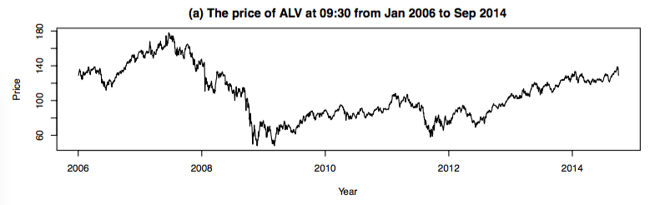

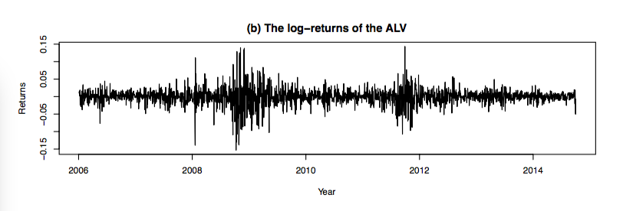

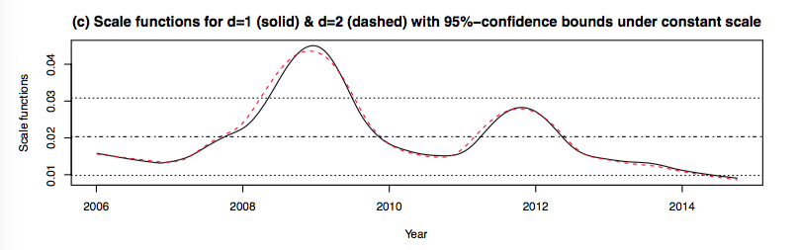

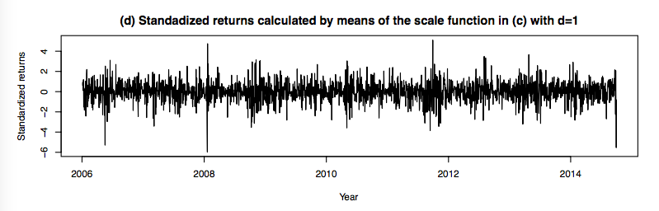

Estimated coefficients for ALV at 09:30

|  |  |  |  |
| --- | --- | --- | --- |
|  | APARCH-t(1,1,) | EGARCH-t(1,1,) | CGARCH-t(1,1,) |
|  | 0.030811 | 0.023525 | 0.046245 |
|  | 0.072068 | -0.008490 | 0.004690 |
|  | 0.065588 | -0.121483 | 0.101784 |
|  | 0.841074 | 0.928114 | 0.835055 |
|  | 0.720705 | 0.172949 | _ |
|  | 1.815581 | _ | _ |
|  | _ | _ | 0.995571 |
|  | _ | _ | 0.000000 |
| shape | 6.506437 | 6.391486 | 6.060666 |

In component GARCH model, the parameters and are represented by (’eta11’) and (’eta21’) respectively.



Tables and figures for ALV at 11:00

|  |  |  |  |
| --- | --- | --- | --- |
|  | APARCH-t(1,1,) | EGARCH-t(1,1,) | CGARCH-t(1,1,) |
|  | 0.027935 | 0.028150 | 0.044178 |
|  | 0.086802 | -0.006788 | 0.005350 |
|  | 0.071707 | -0.120221 | 0.091516 |
|  | 0.833555 | 0.916025 | 0.841185 |
|  | 0.655442 | 0.142740 | _ |
|  | 1.660996 | _ | _ |
|  | _ | _ | 0.994889 |
|  | _ | _ | 0.000000 |
| shape | 7.303654 | 7.136397 | 6.944785 |

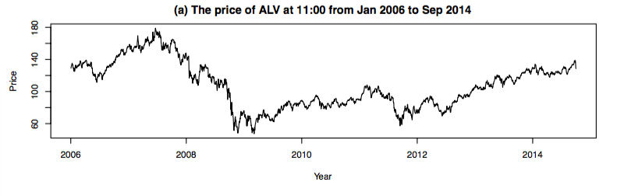

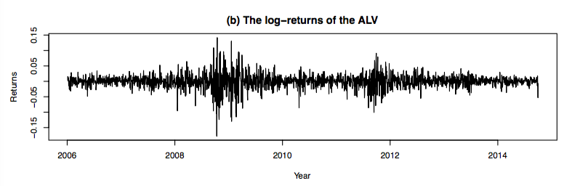

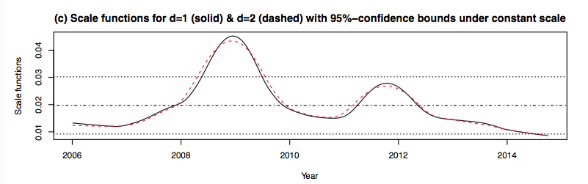

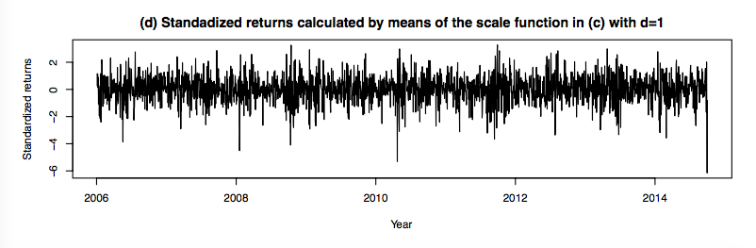

Tables and figures for ALV at 12:30

|  |  |  |  |
| --- | --- | --- | --- |
|  | APARCH-t(1,1,) | EGARCH-t(1,1,) | CGARCH-t(1,1,) |
|  | 0.024217 | 0.020136 | 0.043784 |
|  | 0.085778 | - 0.006793 | 0.003444 |
|  | 0.072438 | - 0.119206 | 0.092086 |
|  | 0.839806 | 0.917423 | 0.833037 |
|  | 0.743891 | 0.143880 | _ |
|  | 1.468959 | _ | _ |
|  | _ | _ | 0.996659 |
|  | _ | _ | 0.000000 |
| shape | 7.915656 | 7.797071 | 7.239844 |

Tables and figures for ALV at 12:30

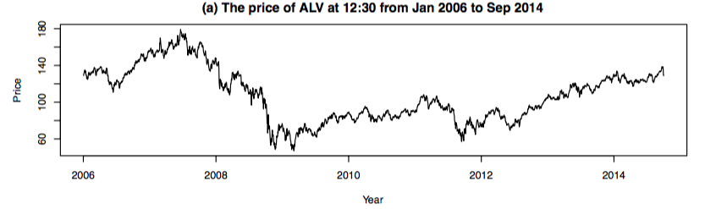

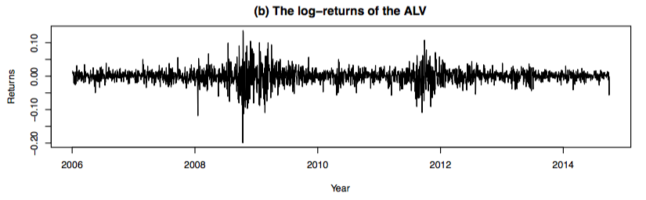

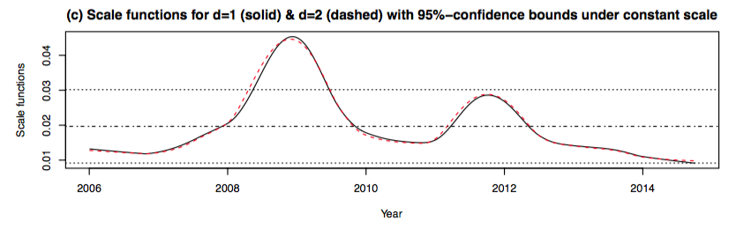

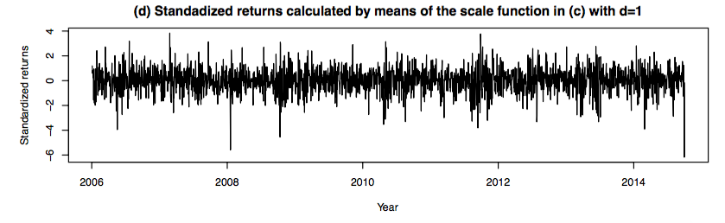

Tables and figures for ALV at 14:00

|  |  |  |  |
| --- | --- | --- | --- |
|  | APARCH-t(1,1,) | EGARCH-t(1,1,) | CGARCH-t(1,1,) |
|  | 0.023732 | 0.023156 | 0.042847 |
|  | 0.095697 | - 0.009432 | 0.003821 |
|  | 0.088357 | - 0.133916 | 0.099963 |
|  | 0.829213 | 0.903927 | 0.820708 |
|  | 0.820682 | 0.164739 | _ |
|  | 1.147269 | _ | _ |
|  | _ | _ | 0.996322 |
|  | _ | _ | 0.000000 |
| shape | 7.431702 | 7.412819 | 6.838452 |

Tables and figures for ALV at 14:00

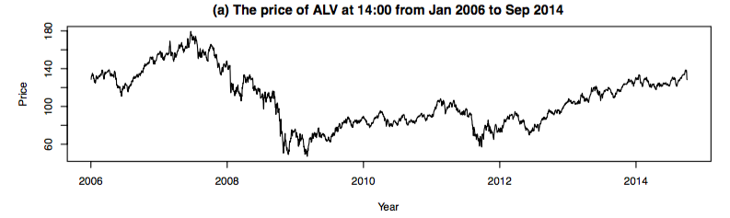

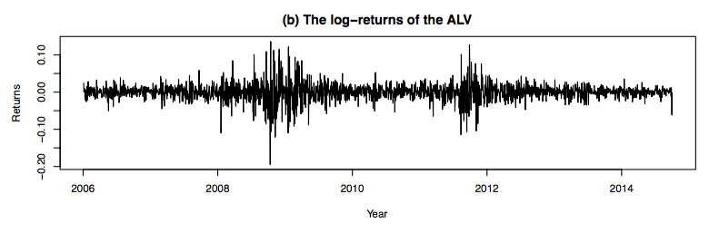

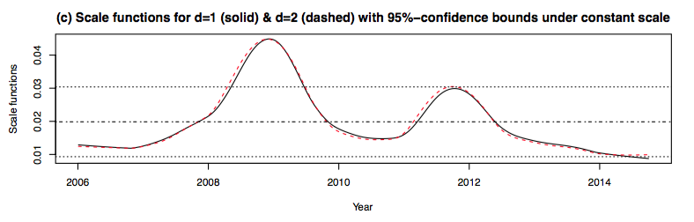

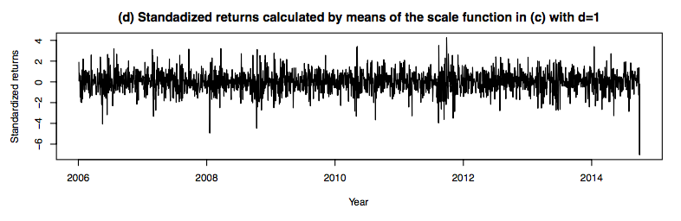

Tables and figures for ALV at 15:30

|  |  |  |  |
| --- | --- | --- | --- |
|  | APARCH-t(1,1,) | EGARCH-t(1,1,) | CGARCH-t(1,1,) |
|  | 0.011890 | 0.008475 | 0.029493 |
|  | 0.070333 | -0.005184 | 0.004089 |
|  | 0.063602 | -0.110778 | 0.083003 |
|  | 0.857014 | 0.928123 | 0.846245 |
|  | 0.664906 | 0.137833 | _ |
|  | 1.736078 | _ | _ |
|  | _ | _ | 0.995975 |
|  | _ | _ | 0.000000 |
| shape | 8.127734 | 7.980692 | 7.692529 |

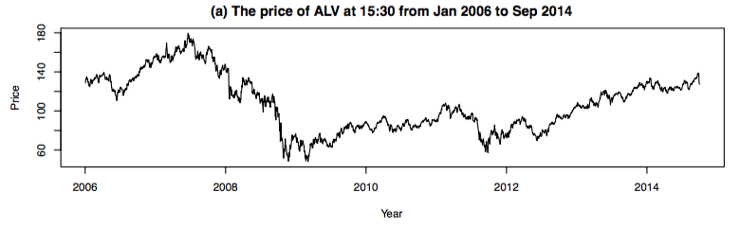

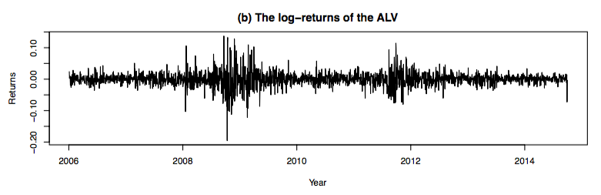

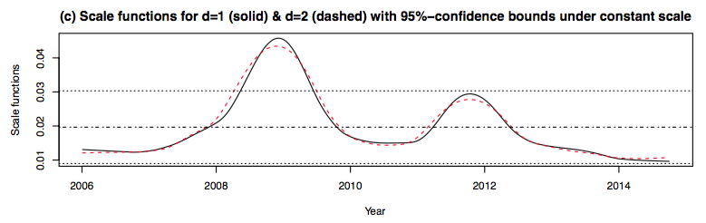

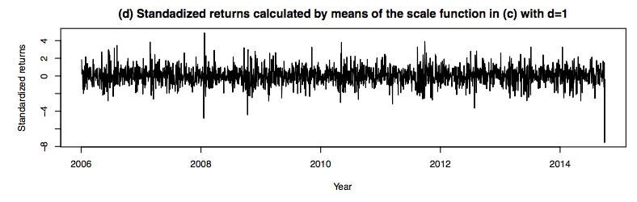

Selected bandwidths in all times (T) of BMW

|  |  |  |  |  |  |
| --- | --- | --- | --- | --- | --- |
|  | T=09:30 | T=11:00 | T=12:30 | T=14:00 | T=15:30 |
| d=1 |  |  |  |  |  |
| d=2 |  |  |  |  |  |

BIC of all selected models for BMW

|  |  |  |  |  |  |
| --- | --- | --- | --- | --- | --- |
|  | T=09:30 | T=11:00 | T=12:30 | T=14:00 | T=15:30 |
| APARCH-t(1,1 |  |  |  |  |  |
| APARCH-t(1,2 |  |  |  |  |  |
| APARCH-t(2,1 |  |  |  |  |  |
| APARCH-t(2,2 |  |  |  |  |  |
| EGARCH-t(1,1) |  |  |  |  |  |
| EGARCH-t(1,2) |  |  |  |  |  |
| EGARCH-t(2,1) |  |  |  |  |  |
| EGARCH-t(2,2) |  |  |  |  |  |
| CGARCH-t(1,1) |  |  |  |  |  |
| CGARCH-t(1,2) |  |  |  |  |  |
| CGARCH-t(2,1) |  |  |  |  |  |
| CGARCH-t(2,2) |  |  |  |  |  |

Tables and figures for BMW at 09:30

|  |  |  |  |
| --- | --- | --- | --- |
|  | APARCH-t(1,1,) | EGARCH-t(1,1,) | CGARCH-t(1,1,) |
|  |  |  |  |
|  |  |  |  |
|  |  |  |  |
|  |  |  |  |
|  |  |  | _ |
|  |  | _ | _ |
|  | _ | _ |  |
|  | _ | _ | 0.000000 |
| shape |  |  |  |

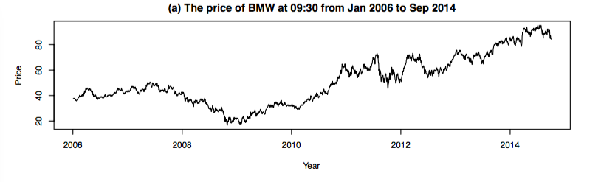

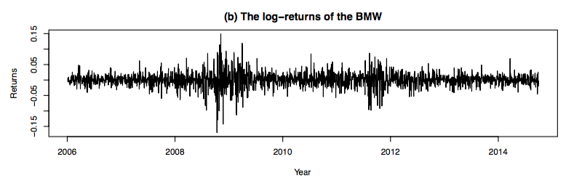

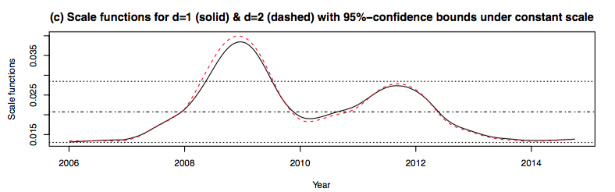

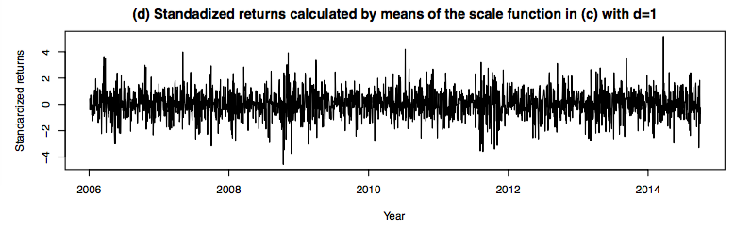

Tables and figures for BMW at 11:00

|  |  |  |  |
| --- | --- | --- | --- |
|  | APARCH-t(1,1,) | EGARCH-t(1,1,) | CGARCH-t(1,1,) |
|  |  |  |  |
|  |  |  |  |
|  |  |  |  |
|  |  |  |  |
|  |  |  | _ |
|  |  | _ | _ |
|  | _ | _ |  |
|  | _ | _ | 0.000000 |
| shape |  |  |  |

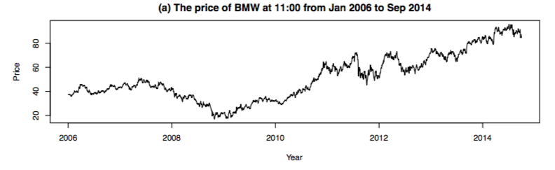

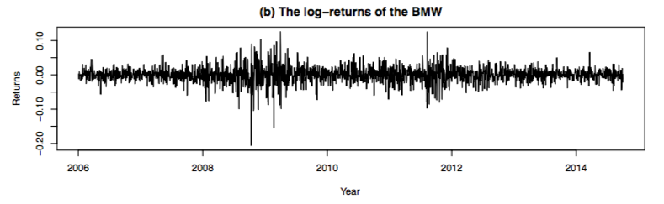

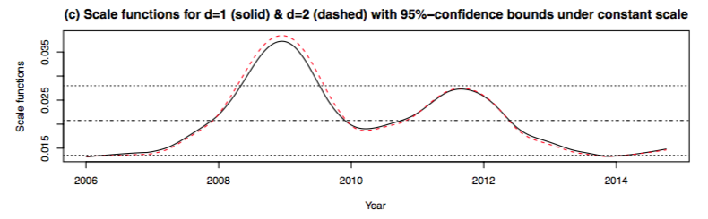

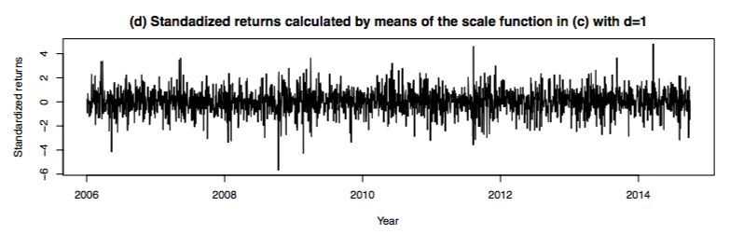

Tables and figures for BMW at 12:30

|  |  |  |  |
| --- | --- | --- | --- |
|  | APARCH-t(1,1,) | EGARCH-t(1,1,) | CGARCH-t(1,1,) |
|  |  |  |  |
|  |  |  |  |
|  |  |  |  |
|  |  |  |  |
|  |  |  | _ |
|  |  | _ | _ |
|  | _ | _ |  |
|  | _ | _ | 0.000000 |
| shape |  |  |  |

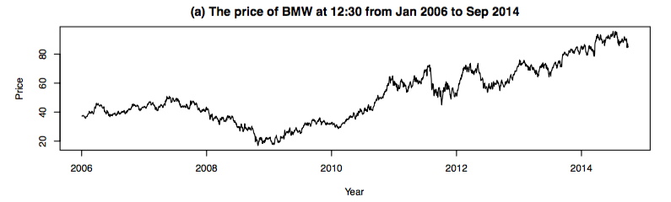

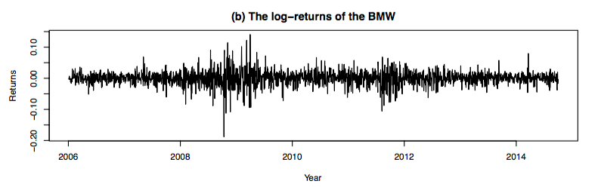

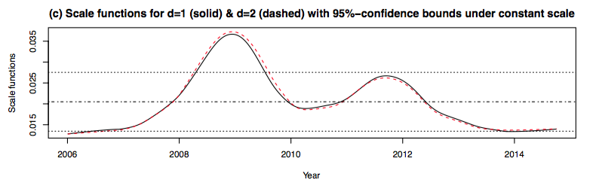

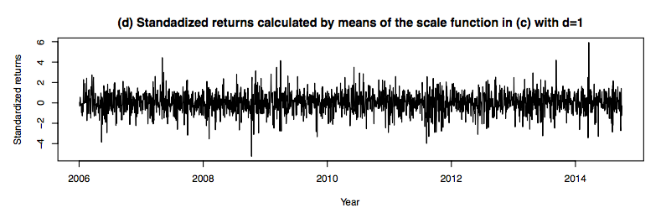

Tables and figures for BMW at 14:00

|  |  |  |  |
| --- | --- | --- | --- |
|  | APARCH-t(1,1,) | EGARCH-t(1,1,) | CGARCH-t(1,1,) |
|  |  |  |  |
|  |  |  |  |
|  |  |  |  |
|  |  |  |  |
|  |  |  | _ |
|  |  | _ | _ |
|  | _ | _ |  |
|  | _ | _ | 0.000000 |
| shape |  |  |  |

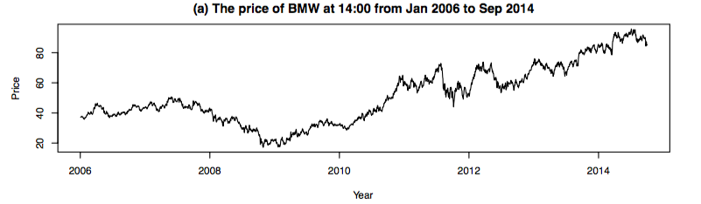

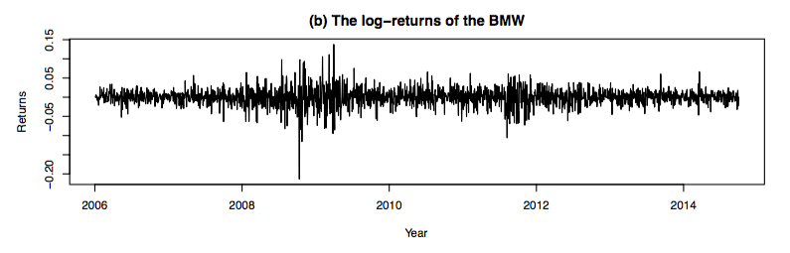

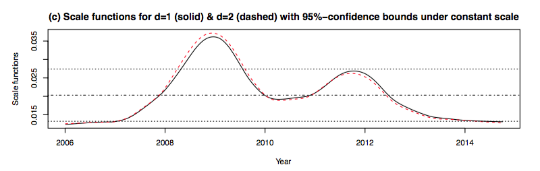

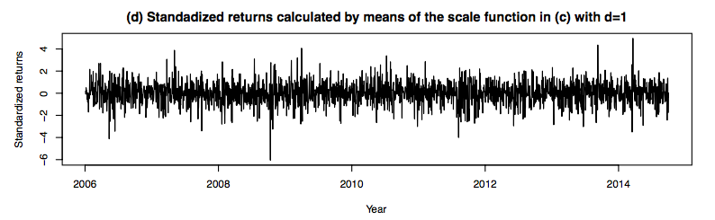

Tables and figures for BMW at 15:30

|  |  |  |  |
| --- | --- | --- | --- |
|  | APARCH-t(1,1,) | EGARCH-t(1,1,) | CGARCH-t(1,1,) |
|  |  |  |  |
|  |  |  |  |
|  |  |  |  |
|  |  |  |  |
|  |  |  | _ |
|  |  | _ | _ |
|  | _ | _ |  |
|  | _ | _ | 0.000000 |
| shape |  |  |  |

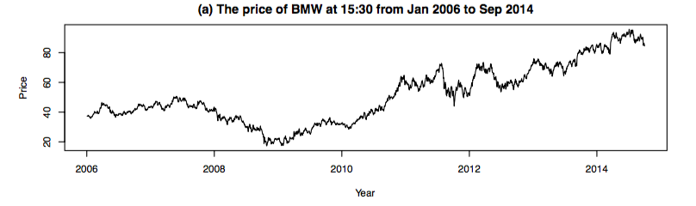

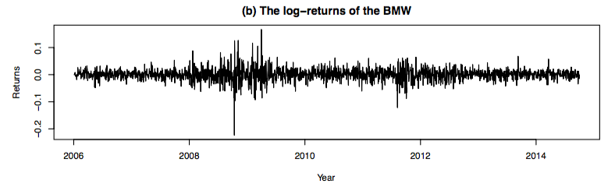

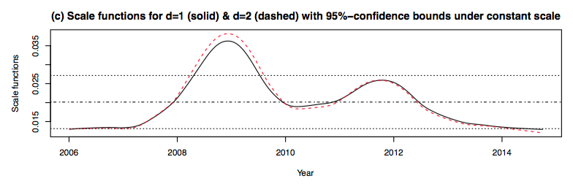

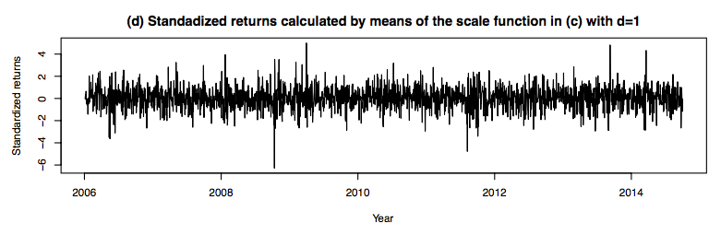

# 5 Conclusion

# Reference

Altman, Naomi, and Christian Léger. 1995. “Bandwidth Selection for Kernel Distribution Function Estimation.” *Journal of Statistical Planning and Inference* 46 (2): 195–214. doi:10.1016/0378-3758(94)00102-2.

Bollerslev, Tim. 1986. “Generalized Autoregressive Conditional Heteroskedasticity.” *Journal of Econometrics* 31: 307–27.

Bollerslev, Tim, Ray Y. Chou, and Kenneth F. Kroner. 1992. “ARCH Modeling in Finance.” *Journal of Econometrics*. doi:10.1016/0304-4076(92)90064-X.

Bougerol, Philippe, and Nico Picard. 1992. “Stationarity of Garch Processes and of Some Nonnegative Time Series.” *Journal of Econometrics* 52 (1-2): 115–27. doi:10.1016/0304-4076(92)90067-2.

Di, Jianing, and Ashis Gangopadhyay. 2011. “On the Efficiency of a Semi-Parametric GARCH Model.” *The Econometrics Journal* 14 (2): 257–77. doi:10.1111/j.1368-423X.2010.00337.x.

Ding, Zhuanxin, Clive W.J. Granger, and Robert F. Engle. 1993. “A Long Memory Property of Stock Market Returns and a New Model.” *Journal of Empirical Finance* 1 (1): 83–106. doi:10.1016/0927-5398(93)90006-D.

Engle, Robert. 2001. “GARCH 101: The Use of ARCH / GARCH Models in Applied Econometrics” 15 (4): 157–68.

Engle, Robert, and Tim Bollerslev. 1986. “Modelling the Persistence of Conditional Variances.” *Econometric Reviews*. doi:10.1080/07474938608800095.

Engle, Robert F. 1982. “Autoregressive Conditional Heteroscedasticity with Estimates of the Variance of United Kingdom Inflation.” *Econometrica* 50 (4): 987–1007. doi:10.2307/1912773.

Engle, Robert F., and Gary G.J. Lee. 1999. *A Long-Run and Short-Run Component Model of Stock Return Volaility*.

Eubank, Randall L., and Wolfgang Härdle. 1993. “Applied Nonparametric Regression.” *Technometrics* 35 (2): 225. doi:10.2307/1269674.

Eugene F. Fama. 1965. “The Behavior of Stock-Market Prices.” *Chicago Journals* 38 (1): 34–105.

Fan, Jianqing. 1991. “Asymptotic Normality for Deconvolution Kernel Density Estimators.” *Journal of Statistical* 53 (1): 97–110. http://arxiv.org/abs/0810.3121.

Fan, Jianqing, and Young K Truong. 1993. “Nonparametric Regression with Errors in Variables.” *The Annals of Statistics*. doi:10.1214/aos/1176349402.

Feng, Yuanhua. 2004. “SIMULTANEOUSLY MODELING CONDITIONAL HETEROSKEDASTICITY AND SCALE CHANGE.” *Econometric Theory*. doi:10.1017/S0266466604203061.

Feng, Yuanhua, and Lixin Sun. 2013. “A Semi-APARCH Approach for Comparing Long-Term and Short-Term Risk in Chinese Financial Market and in Mature Financial Markets § Yuanhua Feng ∗ 1 and Lixin Sun ∗∗ 2 1,” 1–25.

Gasser, T, a Kneip, and W Kohler. 1991. “A Flexible and Fast Method for Automatic Smooting.” *Journal of the American Statistical Association* 86 (415): 643–52.

Gasser, Theo, and Hans-Georg Müller. 1984. “Estimating Regression Functions and Their Derivatives by the Kernel Method.” *Scandinavian Journal of Statistics* 11 (3): 171–85. http://www.jstor.org/stable/4615954.

Ghalanos, Alexios. 2014. “Introduction to the Rugarch Package .” *October*, 1–36.

Glosten, Lawrence R., Ravi Jagannathan, and David E. Runkle. 1993. “On the Relation between the Expected Value and the Volatility of the Nominal Excess Return on Stocks.” *Journal of Finance* 48 (5): 1779–1801. doi:10.2307/2329067.

Gourieroux, Christian, and Alain Monfort. 1992. “Qualitative Threshold ARCH Models.” *Journal of Econometrics* 52 (1-2): 159–99. doi:10.1016/0304-4076(92)90069-4.

Jondeau, Eric, and Michael Rockinger. 2003. “Testing for Differences in the Tails of Stock-Market Returns.” *Journal of Empirical Finance* 10 (5): 559–81. doi:10.1016/S0927-5398(03)00005-7.

Ling, S, and M McAleer. 2002. “Necessary and Sufficient Moment Conditions for the GARCH (r, S) and Asymmetric Power GARCH (r, S) Models.” *Econometric Theory* 18 (3): 722–29. http://journals.cambridge.org/abstract_S0266466602183071.

Malmsten, Hans. 2004. “Evaluating Exponential GARCH Models.” *Finance*, 1–25.

Mandelbrot, Benoit. 1963. “The Variation of Certain Speculative Prices.” *The Journal of Business*. doi:10.1086/294632.

McKenzie, M, and Heather Mitchell. 1999. “Generalised Asymmetric Power ARCH Modeling of Exchange Rate Volatility.” *Applied Financial Economics*.

Milhj, Anders. 2012. “The Moment Structure of ARCH Processes.” *Statistics* 12 (4): 281–92.

Nelson, Daniel B. 1991. “Conditional Heteroskedasticity in Asset Returns: A New Approach.” *Econometrica* 59 (2): 347–70. doi:10.2307/2938260.

Sarda, P. 1993. “Smoothing Parameter Selection for Smooth Distribution Functions.” *Journal of Statistical Planning and Inference* 35 (1): 65–75. doi:10.1016/0378-3758(93)90068-H.

Schwert, G. William. 1990. “Stock Volatility and the Crash of ’87.” *The Review of Financial Studies* 3 (1): 77–102. doi:10.2307/2961959.

Taylor, Stephen. 1986. “Modelling Financial Time Series.” John Wiley, Chichester (UK).

Xinzhong Xu and Stephen J.Taylor. 1994. “The Term Structure of Volatility Implied by Foreign Exchange Options” 29 (1): 57–74. doi:10.2307/2331190.

Zakoian, Jean-Michel. 1994. “Threshold Heteroskedastic Models.” *Journal of Economic Dynamics and Control* 18: 931–55.